**Lab 10**

**Lab 10 - Code**

**people.py**

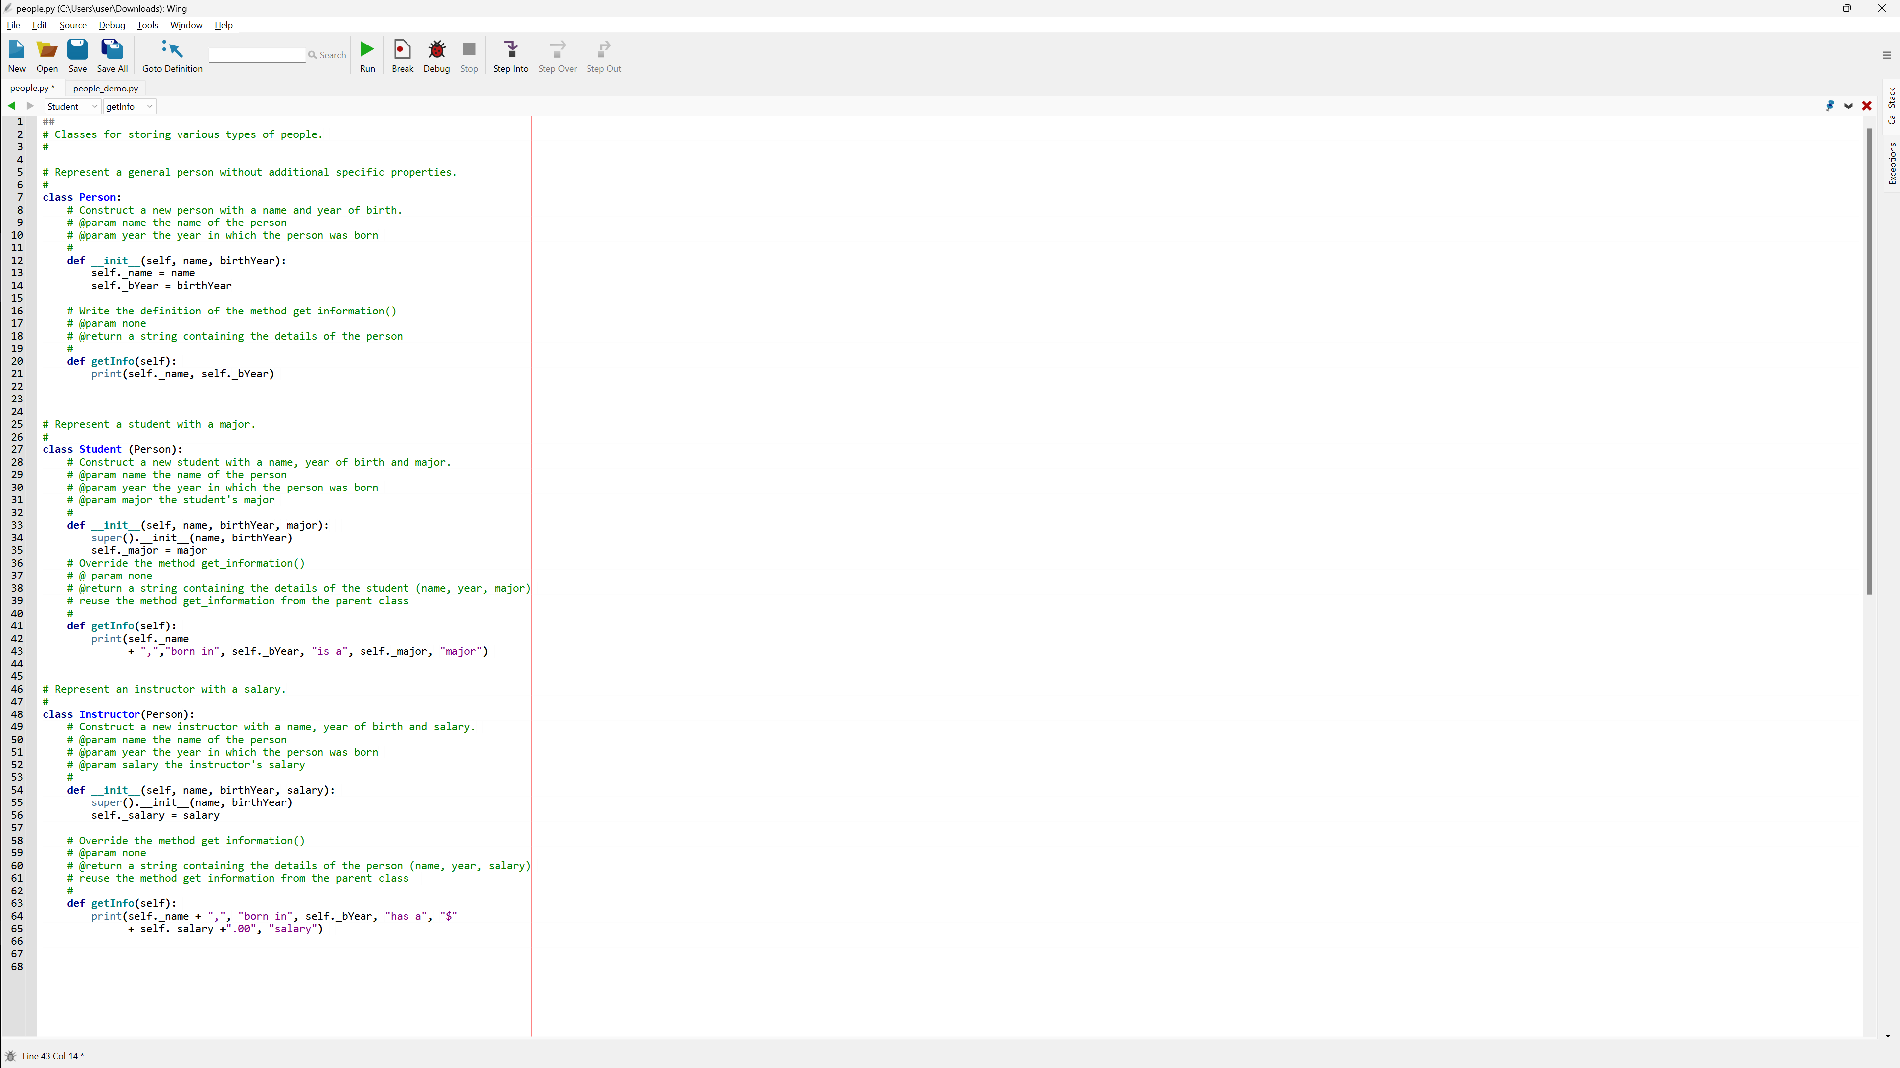

**people_demo.py**

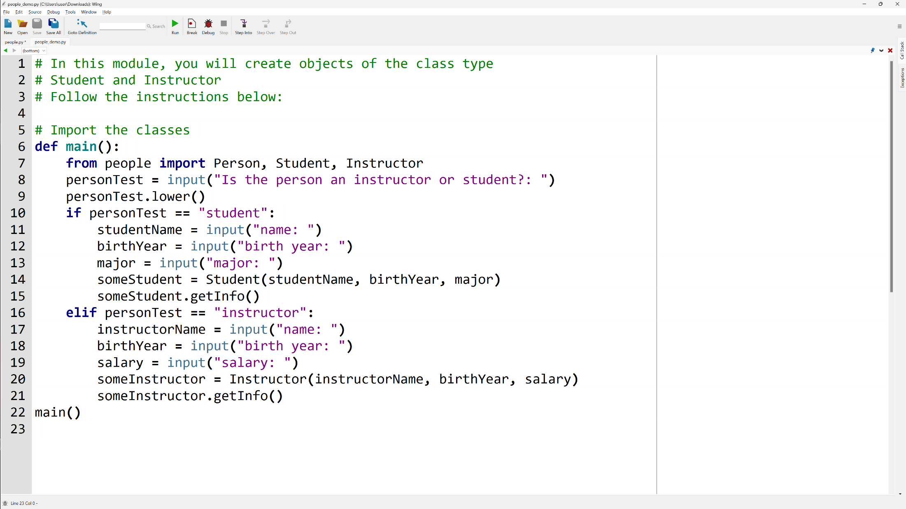

**Lab 10 - Output**

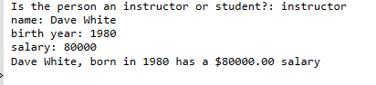

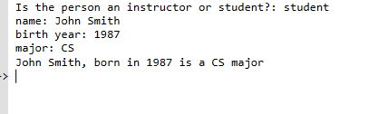

**Lab 10 – Written Code**

**people.py**

##

# Classes for storing various types of people.

#

# Represent a general person without additional specific properties.

#

class Person:

    # Construct a new person with a name and year of birth.

    # @param name the name of the person

    # @param year the year in which the person was born

    #

    def __init__(self, name, birthYear):

        self._name = name

        self._bYear = birthYear

    # Write the definition of the method get information()

    # @param none

    # @return a string containing the details of the person

    #

    def getInfo(self):

        print(self._name, self._bYear)

# Represent a student with a major.

#

class Student (Person):

    # Construct a new student with a name, year of birth and major.

    # @param name the name of the person

    # @param year the year in which the person was born

    # @param major the student's major

    #

    def __init__(self, name, birthYear, major):

        super().__init__(name, birthYear)

        self._major = major

    # Override the method get_information()

    # @ param none

    # @return a string containing the details of the student (name, year, major)

    # reuse the method get_information from the parent class

    #

    def getInfo(self):

        print(self._name + ",","born in", self._bYear, "is a", self._major, "major")

# Represent an instructor with a salary.

#

class Instructor(Person):

    # Construct a new instructor with a name, year of birth and salary.

    # @param name the name of the person

    # @param year the year in which the person was born

    # @param salary the instructor's salary

    #

    def __init__(self, name, birthYear, salary):

        super().__init__(name, birthYear)

        self._salary = salary

    # Override the method get information()

    # @param none

    # @return a string containing the details of the person (name, year, salary)

    # reuse the method get information from the parent class

    #

    def getInfo(self):

        print(self._name + ",", "born in", self._bYear, "has a", "$" + self._salary +".00", "salary")

**people_demo.py**

# In this module, you will create objects of the class type

# Student and Instructor

# Follow the instructions below:

# Import the classes

def main():

    from people import Person, Student, Instructor

    personTest = input("Is the person an instructor or student?: ")

    personTest.lower()

    if personTest == "student":

        studentName = input("name: ")

        birthYear = input("birth year: ")

        major = input("major: ")

        someStudent = Student(studentName, birthYear, major)

        someStudent.getInfo()

    elif personTest == "instructor":

        instructorName = input("name: ")

        birthYear = input("birth year: ")

        salary = input("salary: ")

        someInstructor = Instructor(instructorName, birthYear, salary)

        someInstructor.getInfo()

main()